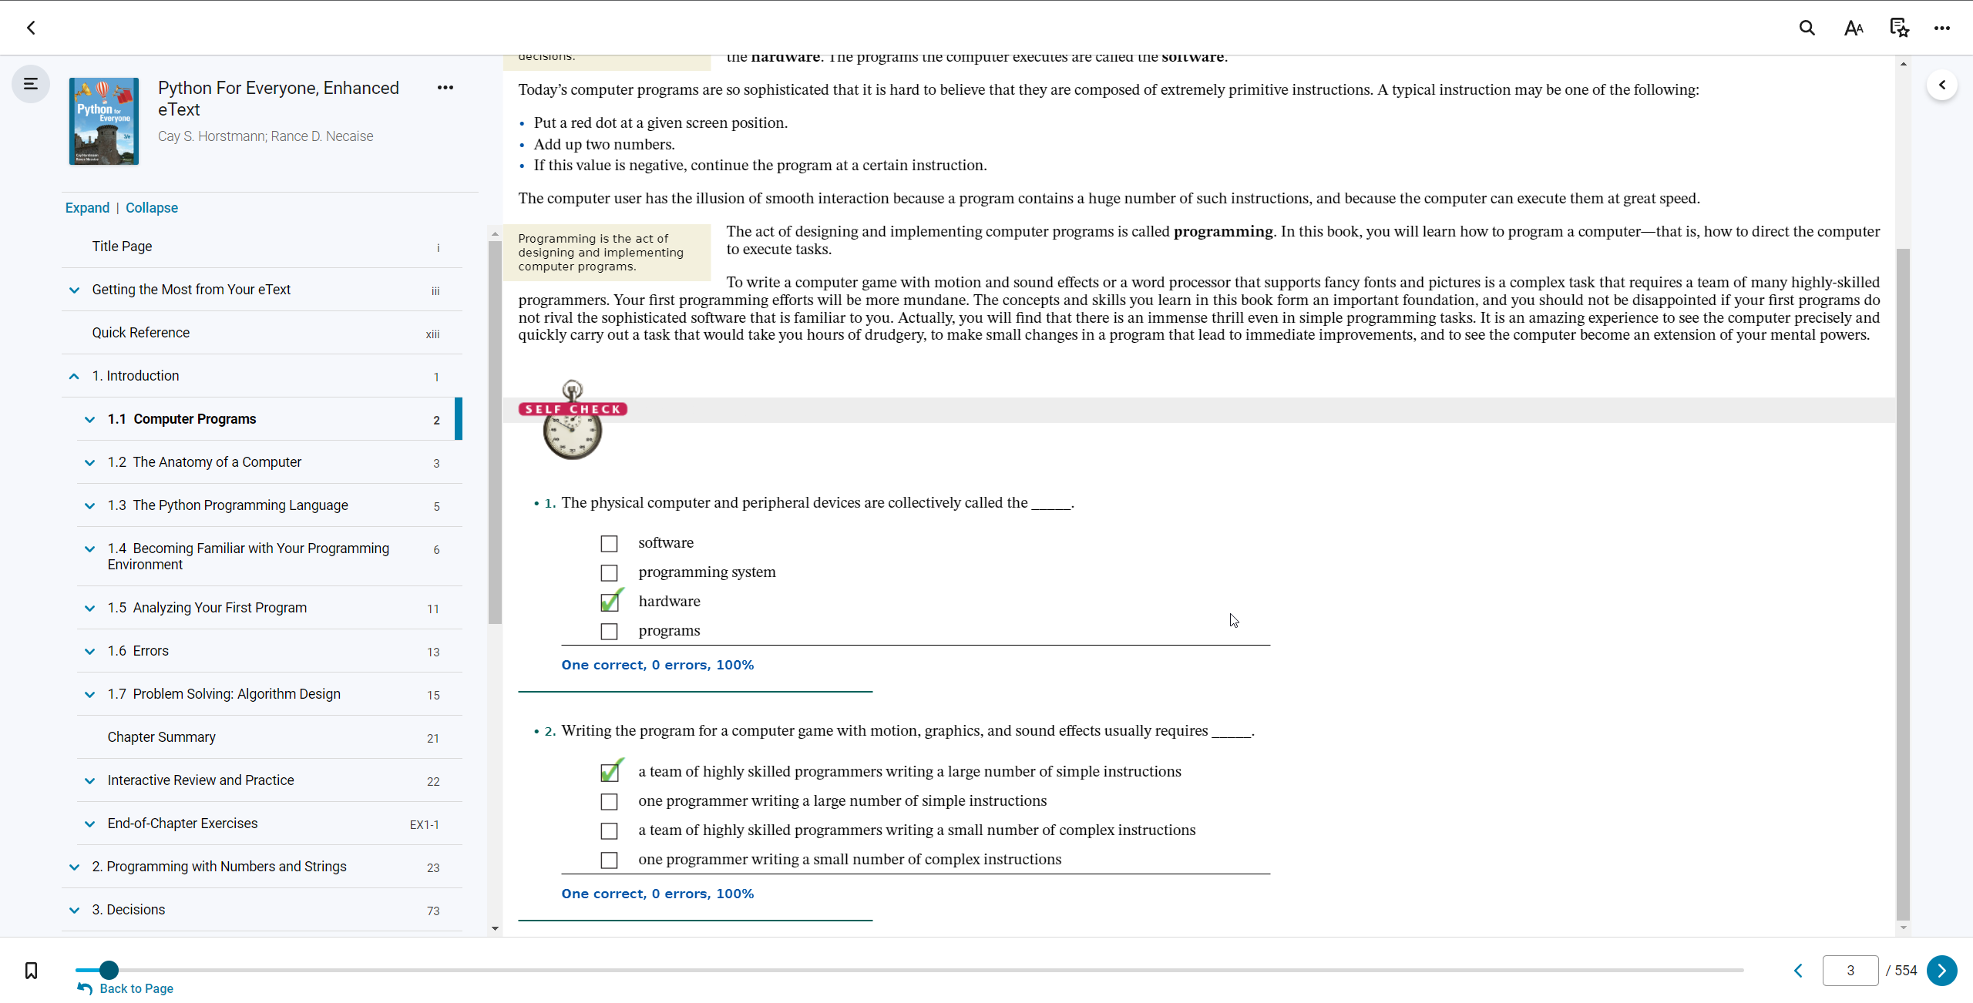

1.1

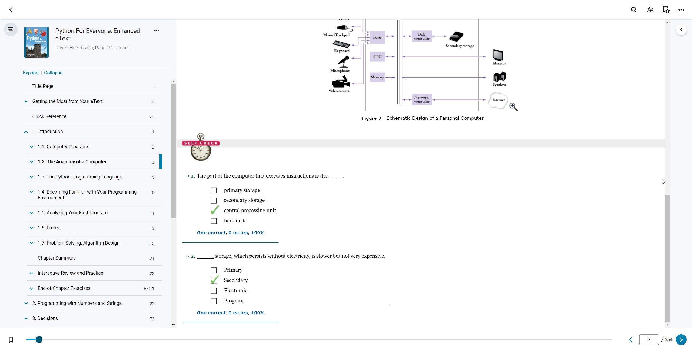

1.2

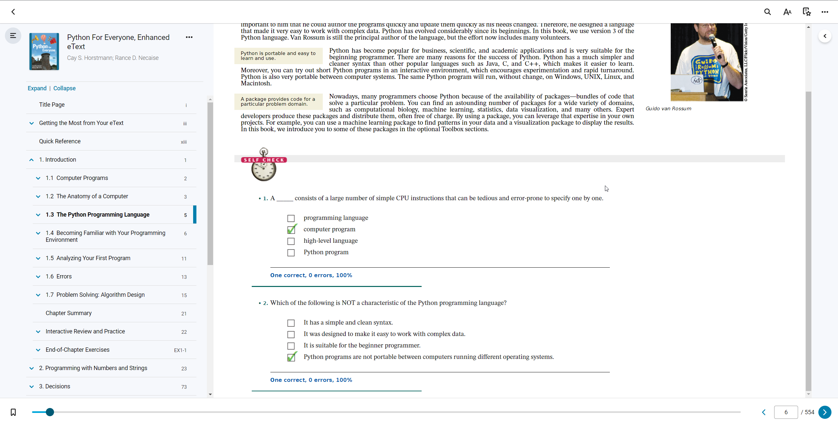

1.3

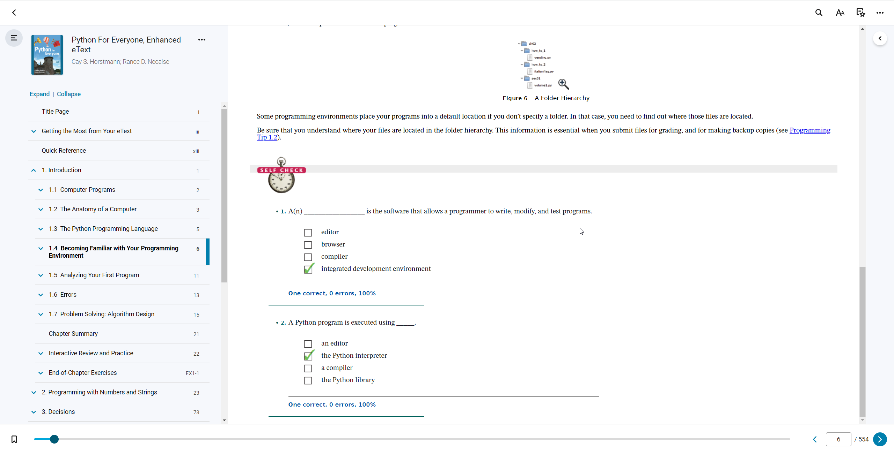

1.4

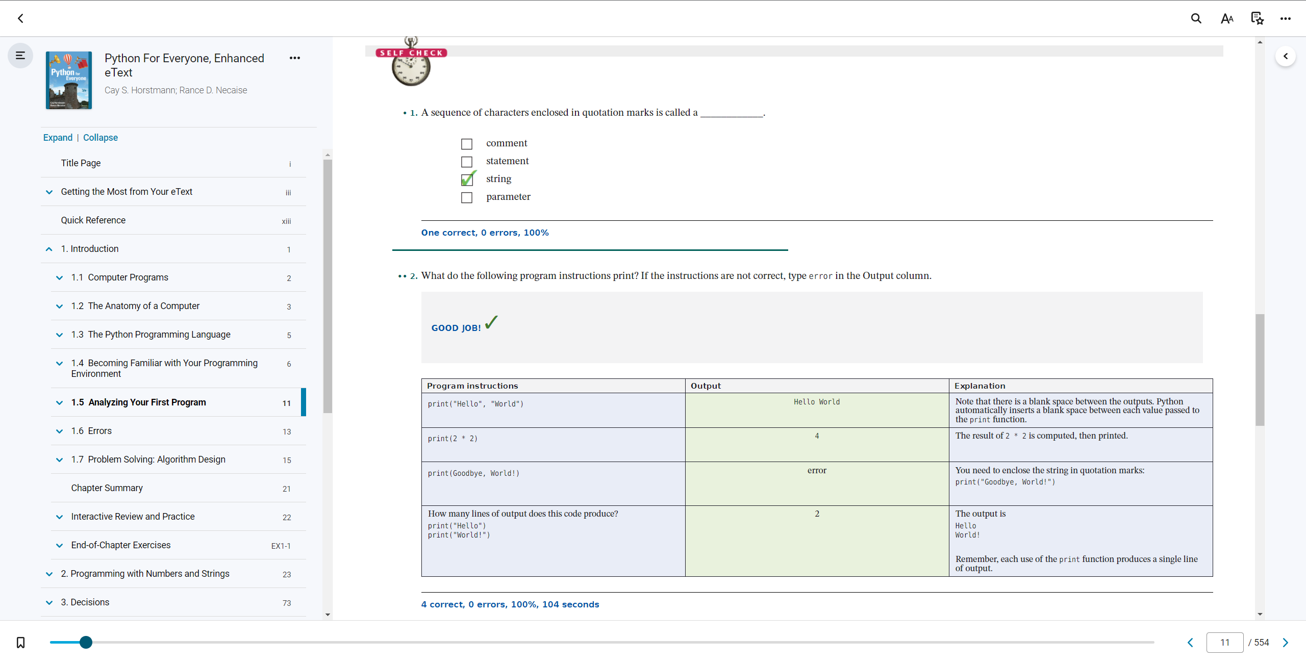

1.5 (p.1)

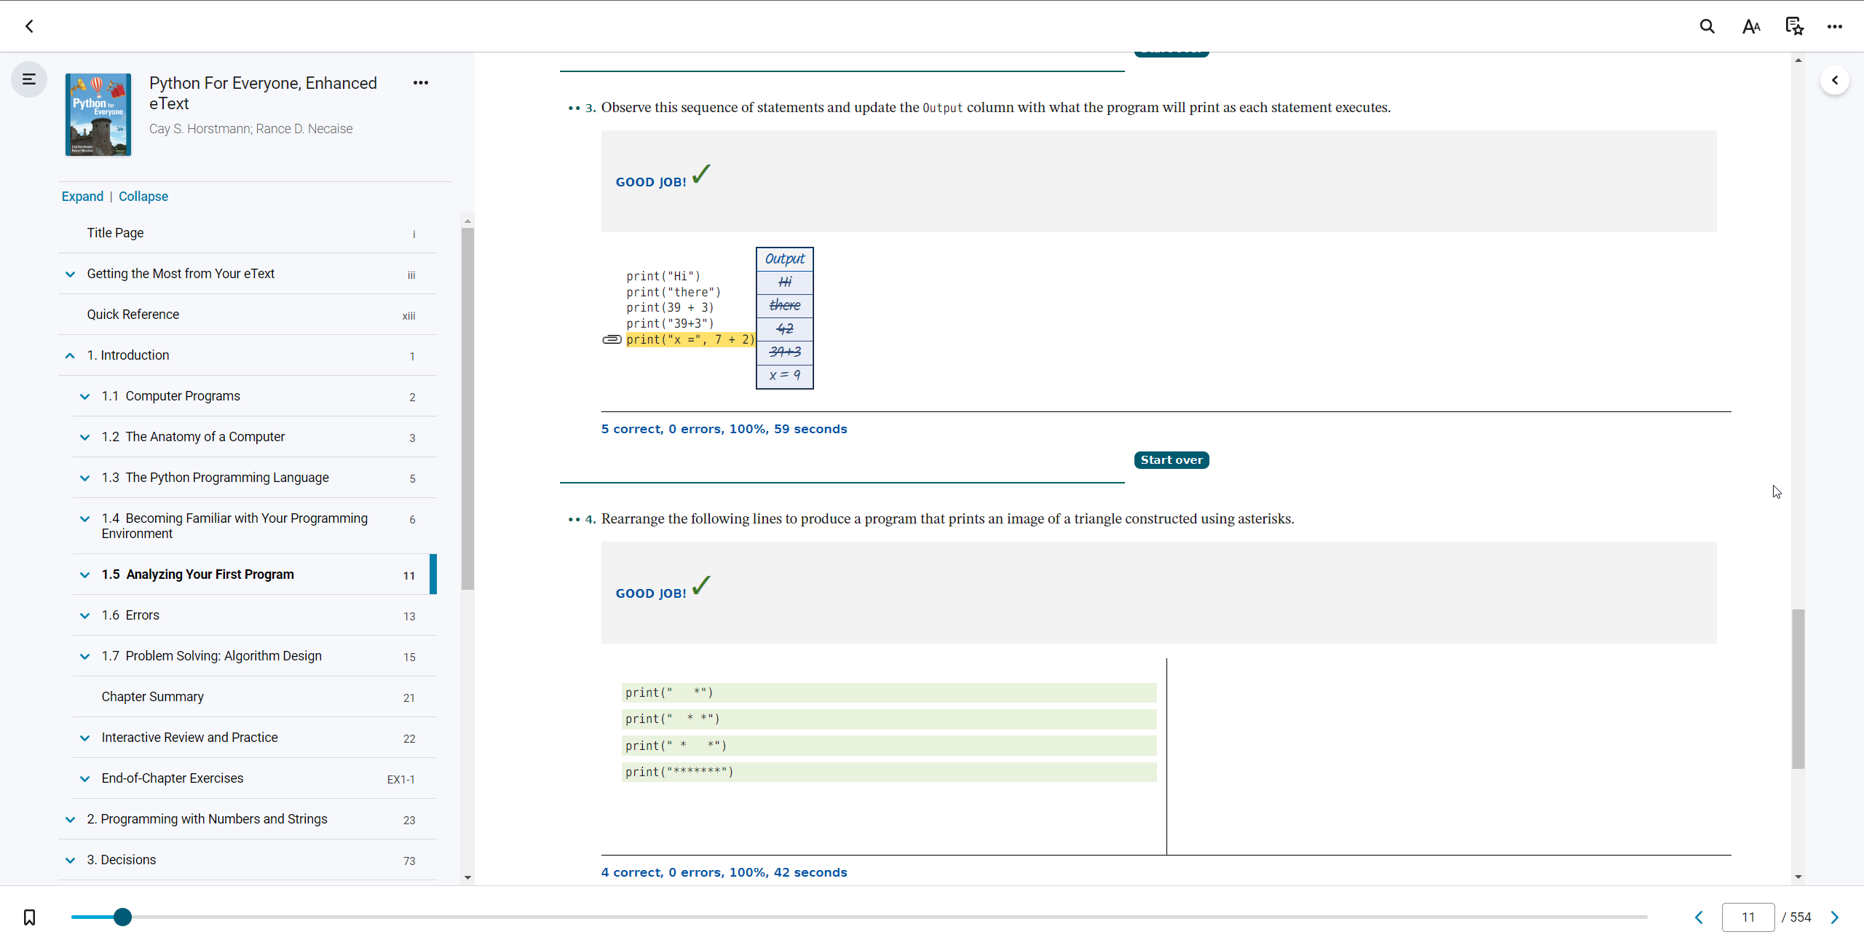

1.5 (p.2)

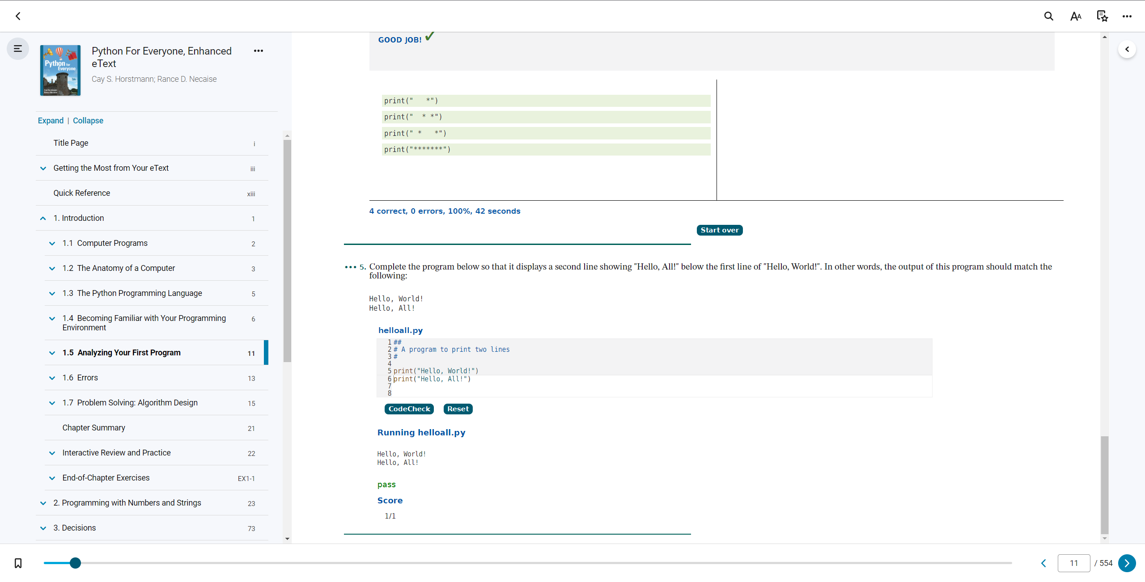

1.5 (p.3)

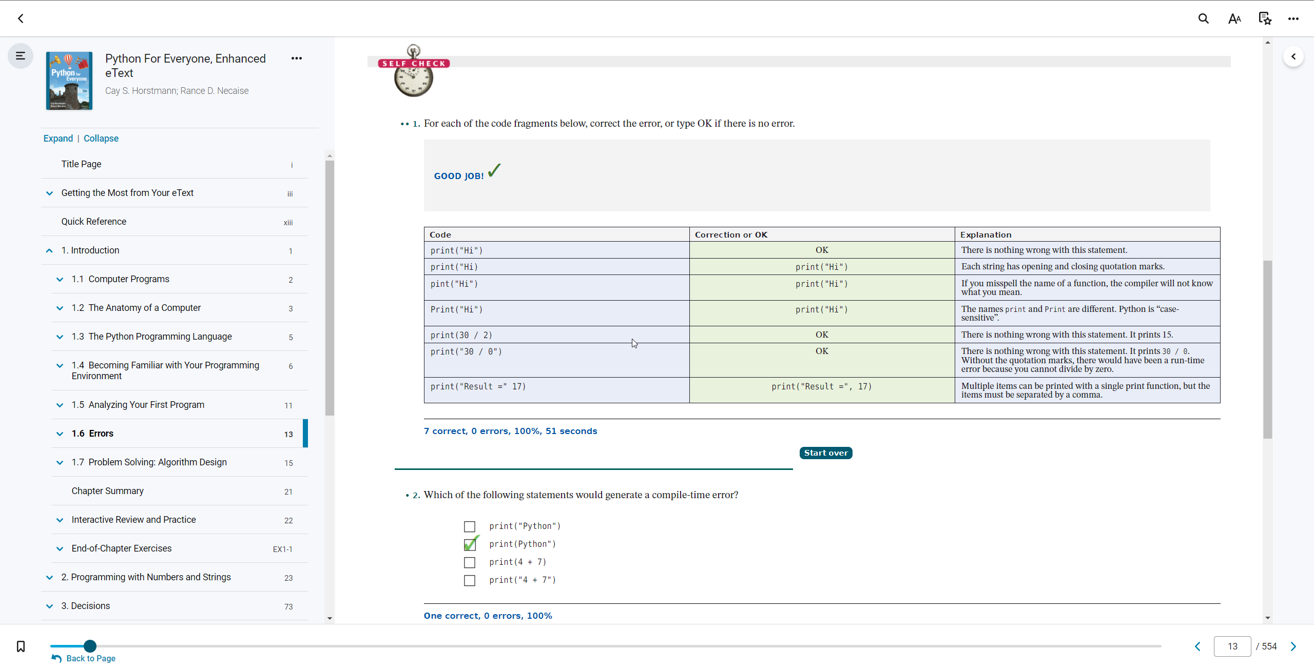

1.6 (p.1)

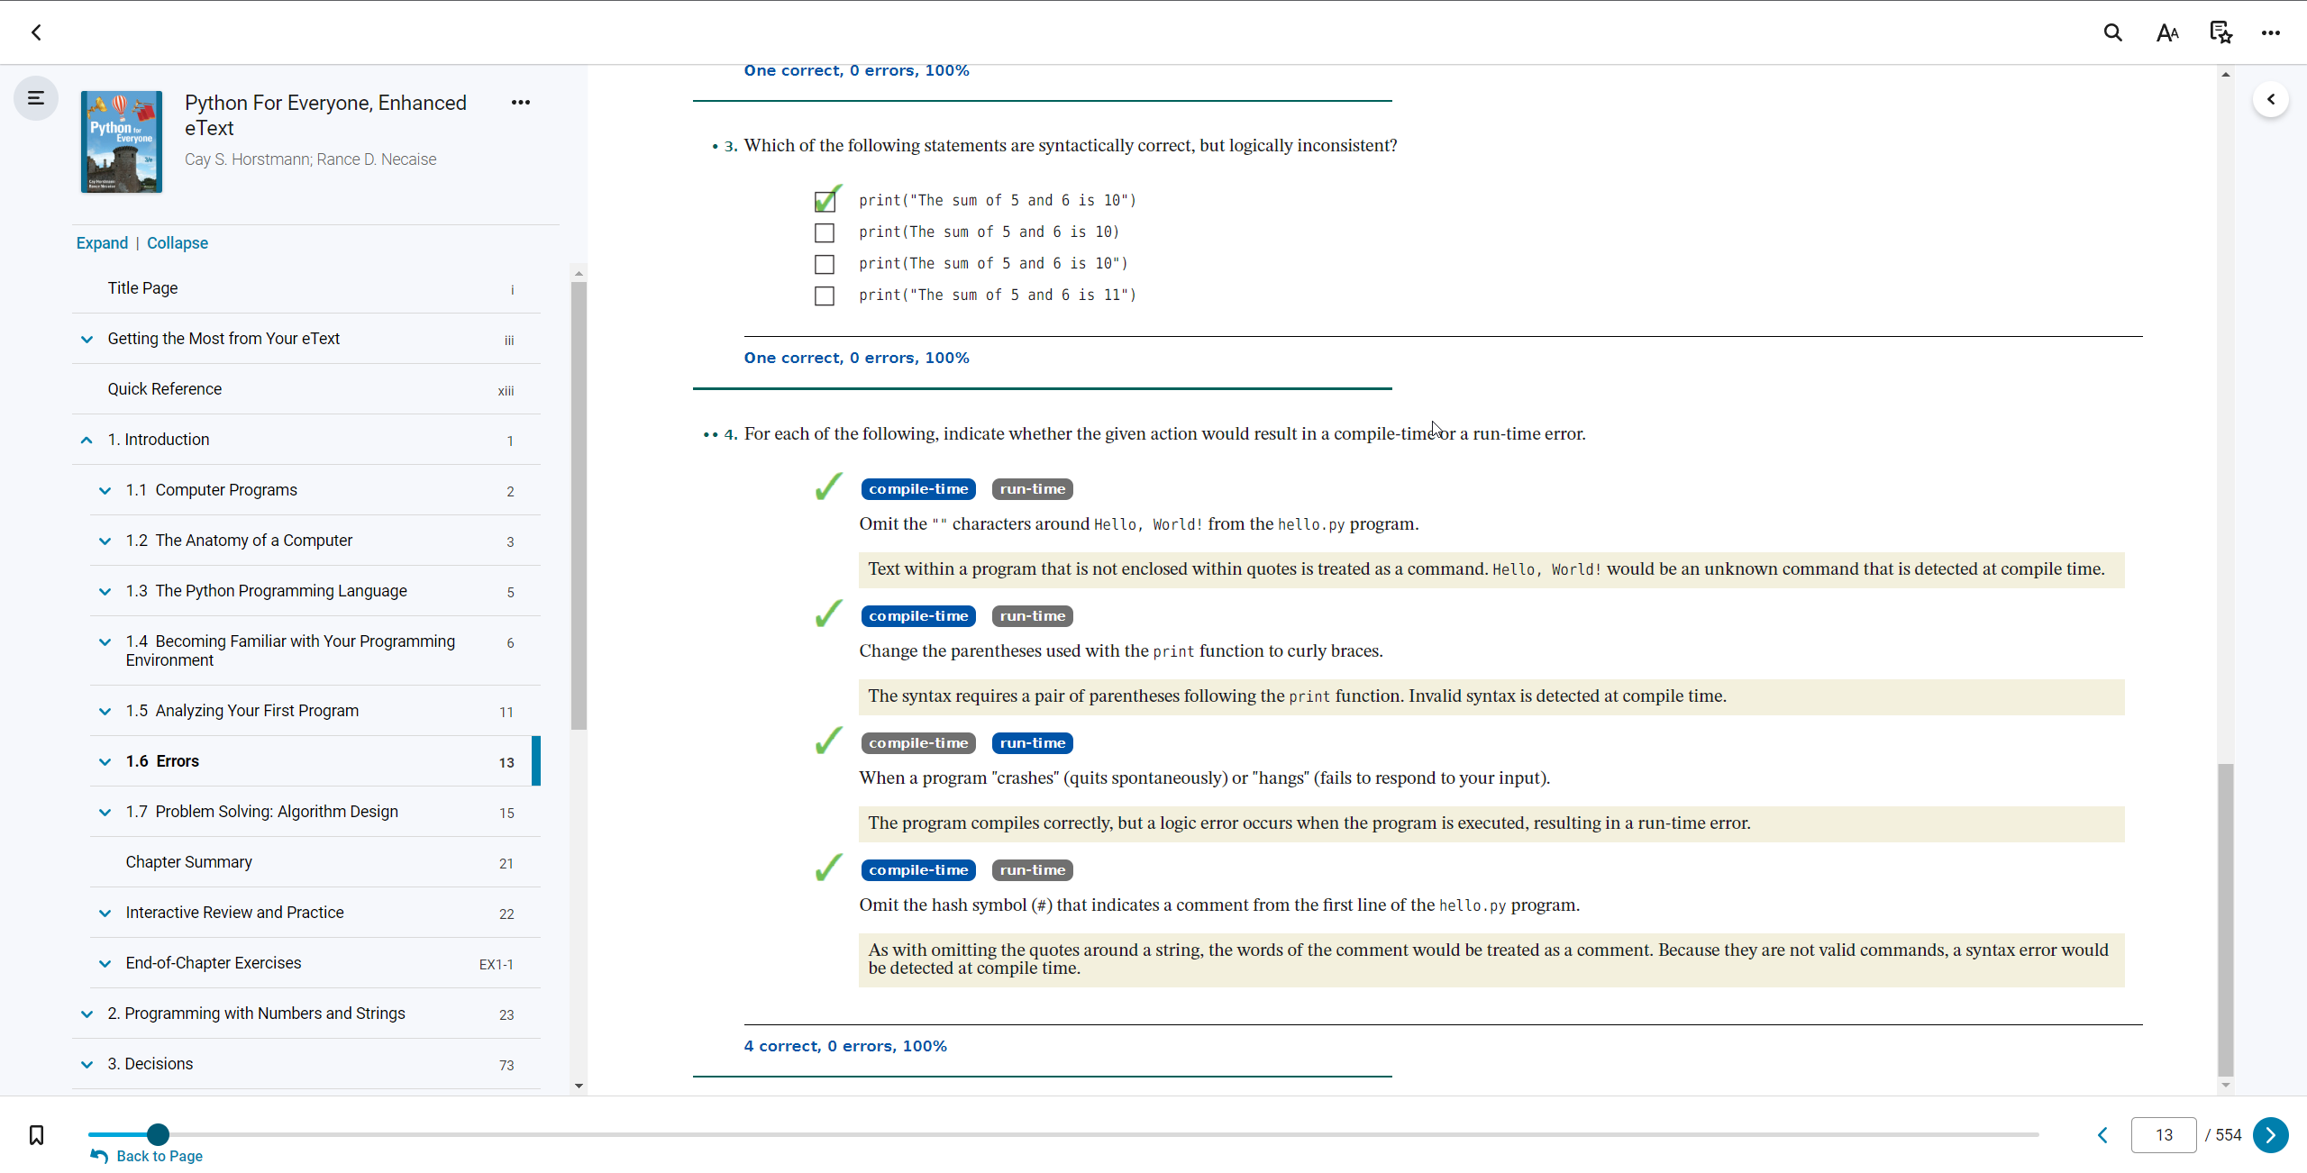

1.6 (p.2)

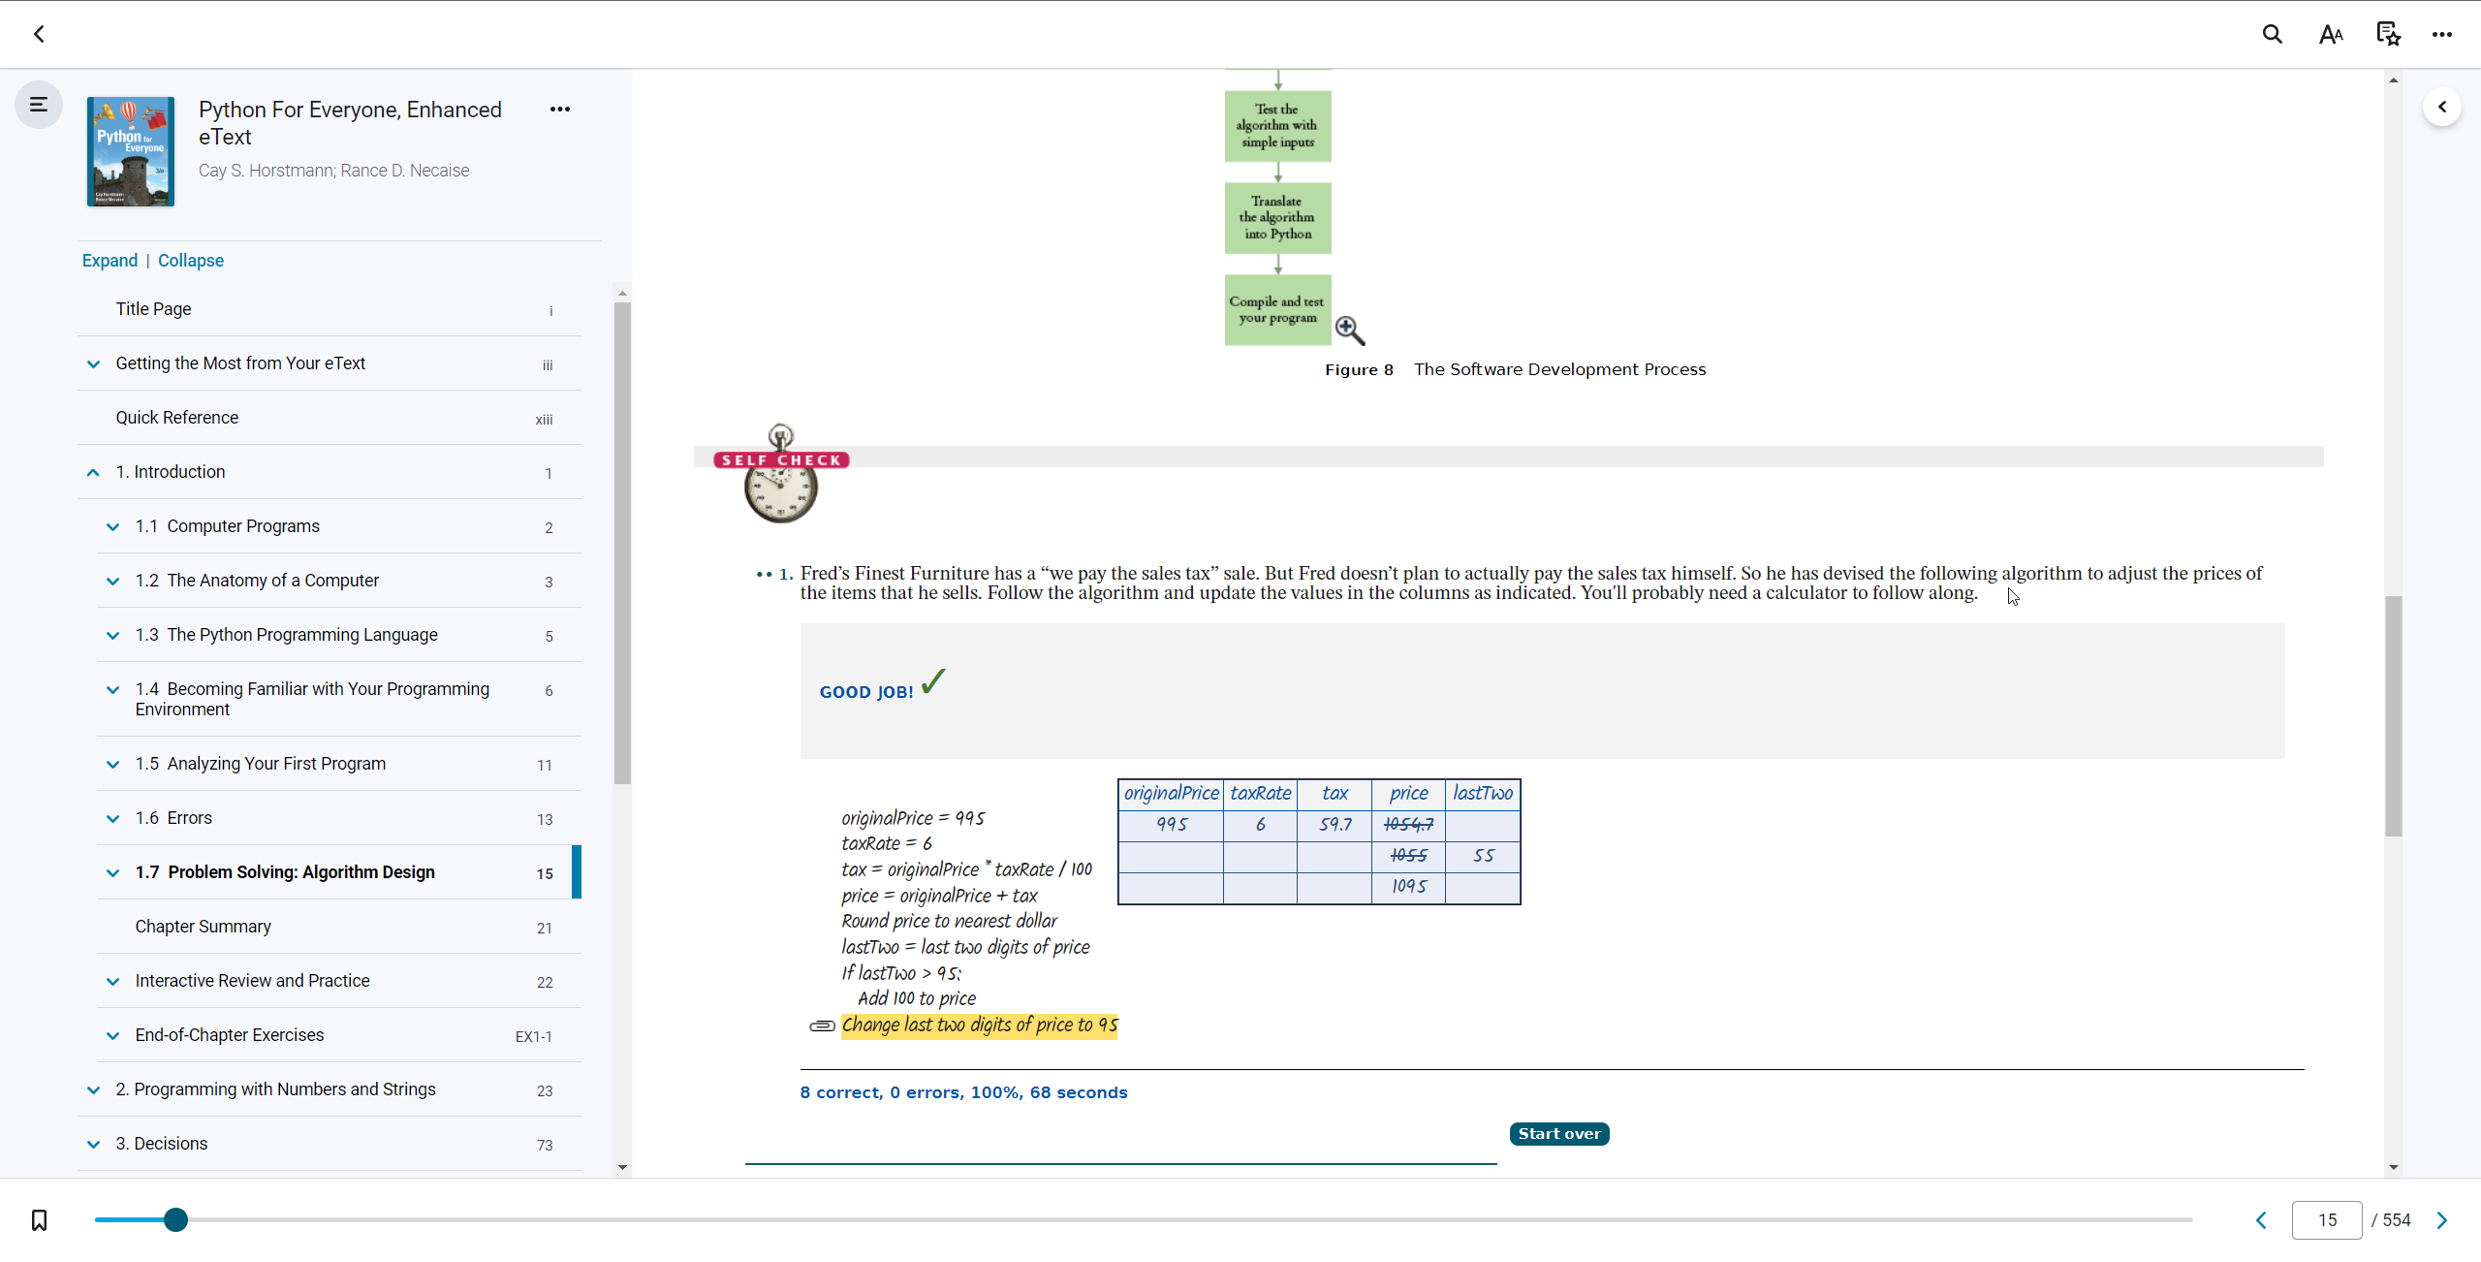

1.7 (p.1)

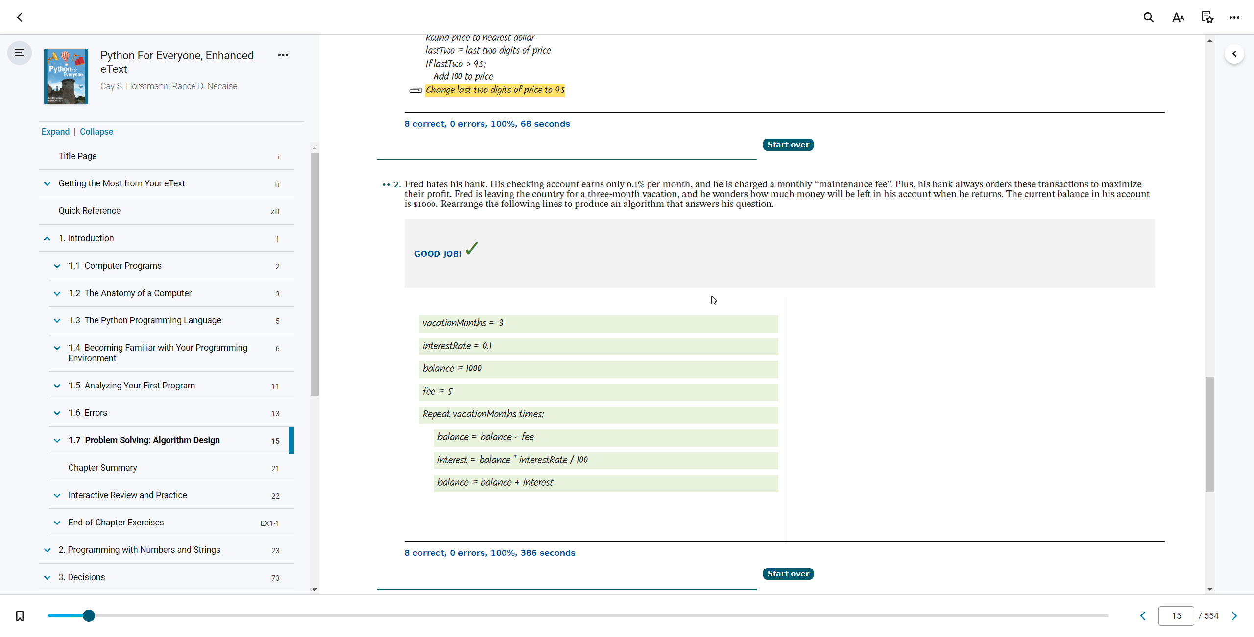

1.7 (p.2)

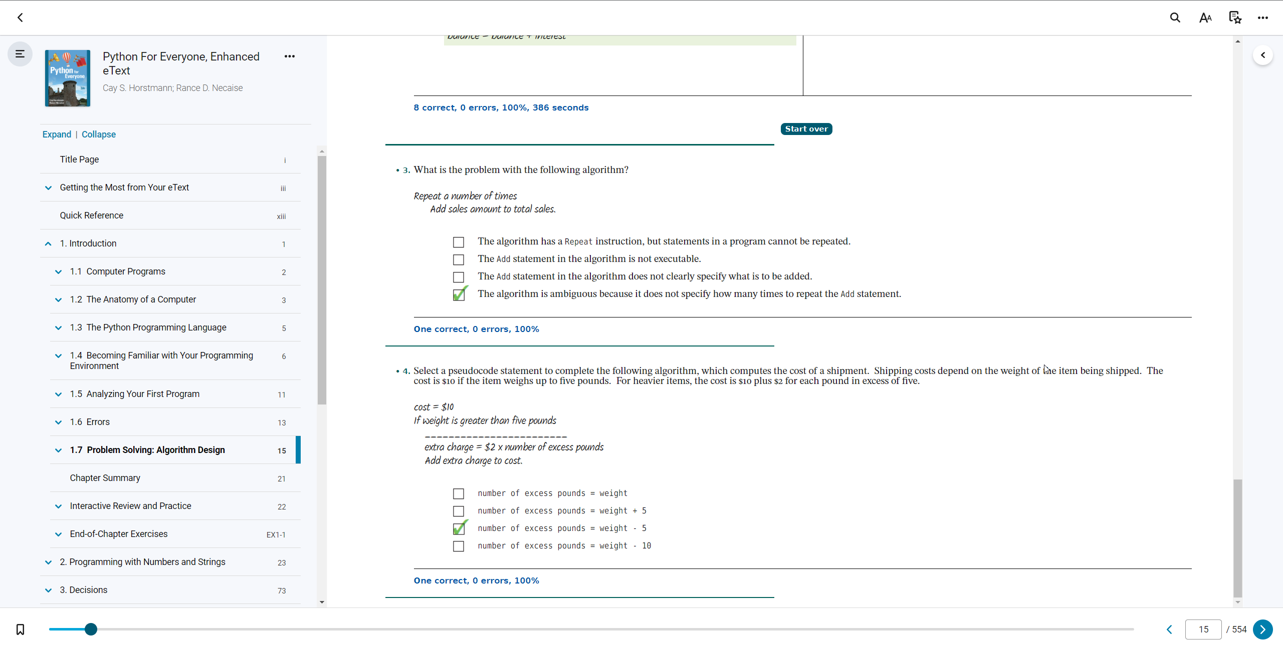

1.7 (p.3)

1.1 Computer Programs (1. & 2)
1.2 The Anatomy of a Computer (1. & 2.)
1.3 The Python Programming Language (1. & 2.)
1.4 Becoming Familiar with Your Programming Environment (1. & 2)
1.5 (p.1) Analyzing Your First Program (1. & 2)
1.5 (p.2) Analyzing Your First Program (3. & 4.)
1.5 (p.3) Analyzing Your First Program (5.)
1.6 (p.1) Errors (1. & 2.)
1.6 (p.2) Errors (3. & 4.)
1.7 (p.1) Problem Solving: Algorithm Design (1.)
1.7 (p.2) Problem Solving: Algorithm Design (2.)
1.7 (p.3) Problem Solving: Algorithm Design (3. & 4.)

